Life Cycle Plan (LCP)

Flower Seeker

Team 05

Name | Roles
Eder Figueroa | Primary Role: Project Manager/ Implementer.  Secondary Role: Tester.
Sophia Wu | Primary Role: Life cycle planner/ Tester  Secondary Role: Implementer
Doris Lam | Primary Role: IIV&Ver/ Quality Focal Point/ Implementer.  Secondary Role: Tester.
Hiram Garcia | Primary Role: IIV&Ver/ Quality Focal Point/ Implementer.  Secondary Role: Tester.

05/01/2013

Version History

Date | Author | Version | Changes made | Rationale
10/03/12 | BY, CZ | 1.0 | - Add Section 3.3 | - Initial draft Section 3.3
10/13/12 | BY, CZ | 2.0 | - Update Section 3.3, Add Section 1 | - Correct errors in Section 3.3 from LCP_VCP_F12a_T05_V1.0. Initial draft Section 1
10/22/12 | YT, EF, SW,BY, CZ | 3.0 | - Update Section 3.3, Add Section 3.1, 3.2, 4, 5 | - Correct errors in Section 3.3 from LCP_FCP_F12a_T05_V2.0. Initial draft Section 4, 5
11/05/12 | YT, EF, SW,BY, CZ | 3.1 | - update of section 2,3,4,5 | - Correct errors from LCP_FCP_F12a_T05_V3.0 and make some modifications based on the recent project development trend
11/26/12 | YT, EF, SW,BY, CZ | 3.2 | - Rename the document  - Correct the mistakes and errors pointed by TA and den student in FCP LCP document. | - Draft DCP
12/06/12 | YT, EF, SW,BY, CZ | 4.1 | - add section 6 till 6.1.3  - update of section 2 and 3 | - Update and correct errors on draft DCP in section 2,3 and 6.
12/10/12 | YT, EF, SW,BY, CZ | 4.2 | - update of section 3 | - correct and update some of the team members' responsibility and role in several phases
02/03/13 | SW | 4.3 | - revise cover | - reform development team
02/11/13 | SW | 4.4 | - revise section 2.1, 3.2, 3.3 and 5 | - reevaluated all aspects of the team
02/13/13 | SW | 4.5 | - revise section 2.1, 2.2, 3.2, 3.3 and 6.1.1-6.1.3 | - Re-assign roles’ responsibilities, reschedule the iteration duration and task and change team members’ skills.
02/20/13 | SW | 4.6 | - Revise section 3.3 | - Assign missing trainer role to some team members
03/30/13 | SW | 4.7 | - Add section 6.1.4, 6.2.1 and 6.3 | - Describe CCD preparation plan
05/01/13 | SW | 4.8 | - Modify section 6.2.1 | - Change the testing result after last iteration

Table of Contents
Life Cycle Plan (LCP) i
Version History ii
Table of Contents iii
Table of Tables iv
Table of Figures v
1. Introduction 1
1.1 Purpose of the LCP 1
1.2 Status of the LCP 1
1.3 Assumptions 1
2. Milestones and Products 2
2.1 Overall Strategy 2
2.2 Project Deliverables 5
3. Responsibilities 9
3.1 Project-specific stakeholder’s responsibilities 9
3.2 Responsibilities by Phase 10
3.3 Skills 12
4. Approach 13
4.1 Monitoring and Control 13
4.2 Methods, Tools and Facilities 14
5. Resources 15
6. Iteration Plan 25
6.1 Plan 25

Table of Tables
Table 1: Artifacts Deliverables in Exploration Phase 5
Table 2: Artifact deliverable in Valuation Phase 5
Table 3: Artifact deliverable in Foundations Phase 6
Table 4: Artifact deliverable in Rebaselined Foundations Phase 7
Table 5: Artifact deliverable in Development (Construction) Phase 8
Table 6: Artifact deliverable in Development (Transition) Phase 9
Table 7: Project-specific stakeholder’s responsibilities 9
Table 8: Stakeholder's Responsibilities in each phase (Fall 2012) 10
Table 9: Stakeholder's Responsibilities in each Phase (Spring 2013) 11
Table 10: COCOMOII Scale Driver 15
Table 11: COCOMOII Cost Driver-payment 16
Table 12: COCOMOII Cost Driver- rank & review 17
Table 13: COCOMOII Cost Driver- order management 18
Table 14: COCOMOII Cost Driver - searching 20
Table 15: COCOMOII Cost Driver – user management 21
Table 16: COCOMOII Cost Driver – product management 23
Table 17: Construction iteration capabilities to be implemented 25
Table 18: Construction iteration capabilities to be tested 26

Table of Figures
Figure 1: Architected Agile Process Pattern & Use Single NDI Process Pattern 2
Figure 2: NDI-Intensive Process Pattern & Net-Centric Service Process Pattern 2
Figure 3: COCOMO II Scale Factors 15
Figure 4: COCOMO II EAF – payment 17
Figure 5: COCOMO II EAF – rank& review 18
Figure 6: COCOMO II EAF – order management 19
Figure 7: COCOMO II EAF – searching 21
Figure 8: COCOMO II EAF – user management 22
Figure 9: COCOMO II EAF – product management 24
Figure 10: COCOMO II of Flowerseeker 24
Figure 11: COCOMO II of FlowerSeeker 25

    - Introduction

Purpose of the LCP
The purpose of LCP document is to show the objective of this project, to show the assumptions this project based on, to show the place where we do this project, to identify responsibilities and skills for each role, to record milestones at each phase, and to record the approaches that are used to achieve these goals.

Status of the LCP
This is the 3.2 edition of Life cycle plan for Development commitment package. This time we completed section 1-5 of this file and make some modifications on the section1.3, 2.2, 3.2, 4.2, and 5 based on TA's comments and change of project plan.

Assumptions
(1)The duration of the projuct is two semester about 24 weeks from 2012 fall to 2013 spring
(2)The team has 2 on-campus students and 2 den students
(3) All clients and other non-student stakeholders are clear about their duty and have the commitment that they will fulfill their job until the end of the project development period.
(4) Students are clear about their duty and have the commitment that they will fulfill their job until the end of the project development period.
(5) Client will provide a server for us to develop the system.

    - Milestones and Products

Overall Strategy
Figure 1: Architected Agile Process Pattern & Use Single NDI Process Pattern
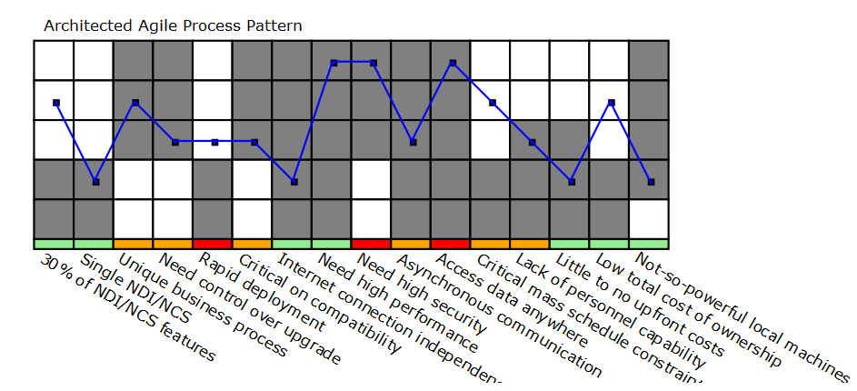
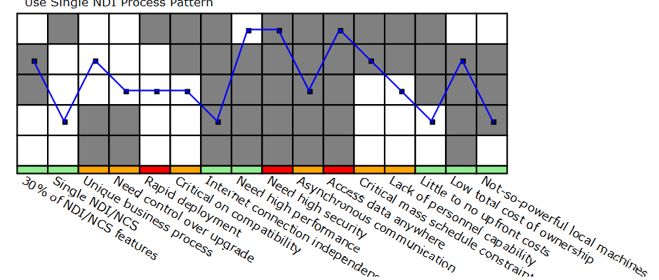

Figure 2: NDI-Intensive Process Pattern & Net-Centric Service Process Pattern
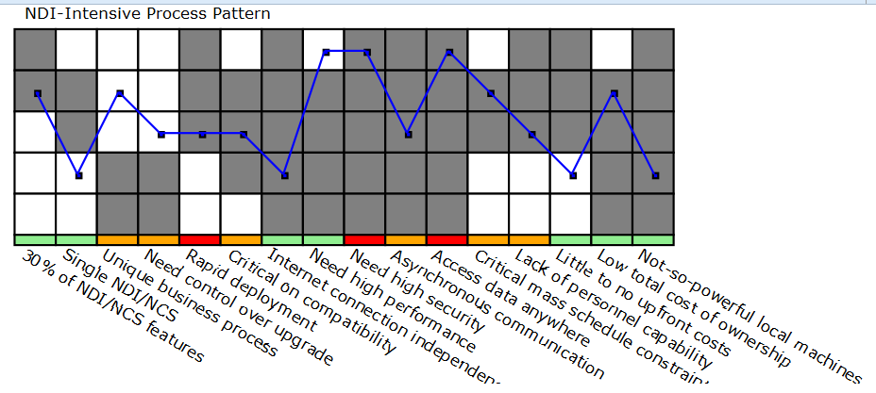
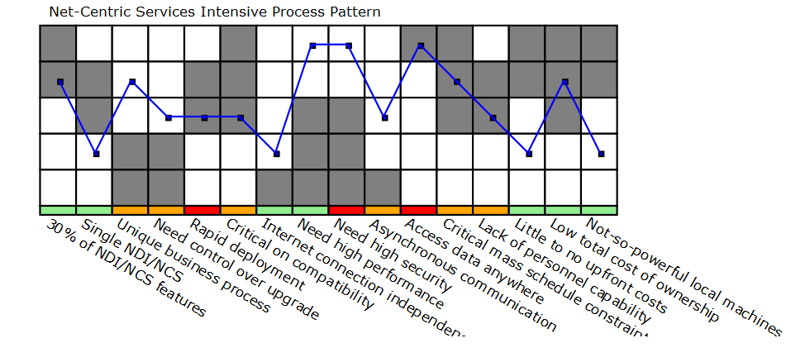
Architected agile is been proved to be the most suitable process pattern for FlowerSeeker. Mainly FlowerSeeker does not use a single NDI/NCS that is going to provide more than 30% of all desired functionality, the reason is that the client wants to personalize almost every single feature and adjust it to her new business flow. Also the project is in some way unique. What makes appealing Flower Seeker is that both florist and customers are going to work altogether without intermediaries, this is different from the current flower ecommerce business work, where florist only sale flowers to the wholesaler. The system design needs to be built to provide high levels of security involving confidentiality, integrity, availability.
The process decision driver allowed us to evaluate characteristics that were not view in previous planning documents and how they could affect the system development in a holistic way for example: unique business process, not so powerful computers, and low budget altogether and not as individual variables.
The project is going to be fully dependent on internet connections, similarly the system need to be able to run in any web-browser that trigger the system in mobile devices, desktop and so on. Architected agile approach can let the development team to build many of these features from scratch with almost 100% customization allowance and requirements satisfaction. Although the system is going to be created from scratch some NCS are going to be included, specially to handle bank-customer communication when a user is paying for a florist arrangement. Also risk management in the other approaches may take longer time for our 24 week course.

Exploration phase
Duration: 09/12/2012- 10/8/2012
Concept: During the Exploration phase, the team set up several meetings to understanding flower business, identifying project operational concept, life cycle plan, and system and software boundary, understanding all success-critical stakeholders, team members’ skills, and identifies risks and mitigation plan for each risk.
Deliverables: Valuation Commitment Package
Milestone: Valuation Commitment Review
Strategy: One Incremental Commitment Cycle
Valuation phase
Duration: 10/9/2012- 11/12/2012
Concept: During the Valuation phase, the team prioritizes win conditions, minimum marketable features and capabilities of FlowerSeeker and elaborates use-cases and UI prototypes on all critical functionality. The team continue revise and complete operational concept, business workflow, creating a draft of system and software architecture, and deciding the process pattern the team should follow.
Deliverables: Foundations Commitment Package
Milestone: Foundations Commitment Review
Strategy: Win-win negotiation, prototype development for critical functionality

Foundation phase
Duration: 11/02/2012 - 12/06/2012
Concept: In this phase, we will first mainly focus to develop the system architecture by define the tech-dependent architecture and make the architecture pattern and frameworks clear.
Deliverables: Development Commitment Package
Milestone: Development commitment review
Strategy: Based on our prototyping and

Rebaselined Foundation phase
Duration: 1/14/13 - 2/15/13
Concept: Since the development team has reformed in current semester that team responsibilities should be reassigned and based on current team size the project modules also be reevaluated.
Deliverables: Rebaselined development commitment package
Milestone: Rebaselined development commitment review
Strategy: revising the previous document and update them based on the changes of the project during the semester break.

Development (construction iteration) phase
Duration: 2/16/13 – 4/19/13
Concept: In this phase, our team will mainly focus on the coding part of the project by buildup the website, database, tracking system and implement all other detail functions of the project.
Deliverables: Initial Operational Capability (IOC) Package, Core Capability Drive-Thru Report, Transition Readiness Review Package
Milestone: Core capability Drive through, Transition Readiness Review
Strategy: Team coding with communications.

Development (transition iteration) phase
Duration: 4/20/13 - 05/03/13
Concept: In the phase, out team will be mainly focused on the transition of the project, which is to train other people to maintain, control and use it.
Deliverables: Support and Transition Set Package.
Milestone: Operation Commitment Review
Strategy: Training

Project Deliverables

Exploration Phase
Table 1: Artifacts Deliverables in Exploration Phase
Artifact | Due date | Format | Medium
Client Interaction Report | 09/19/2012 | .doc, .pdf | Soft copy
Valuation Commitment Package  - Operational Concept Description (OCD) Early Section  - Life Cycle Plan (LCP) Early Section  - Feasibility Evidence Description (FED) Early Section | 10/03/2012 | .doc, .pdf | Soft copy
Evaluation of Valuation Commitment Package | 10/08/2012 | .xls | Soft copy
Project Effort Report | Every Monday | text | ER system
Project Plan | Every Wednesday | .mpp, .pdf | Soft copy
Progress Report | Every Wednesday | .xls | Soft copy

Valuation Phase
Table 2: Artifact deliverable in Valuation Phase
Artifact | Due date | Format | Medium
Core Foundation Commitment Package  - Operational Concept Description (OCD)  - Life Cycle Plan (LCP) Section 1 and 3.3  - Feasibility Evidence Description (FED) Section 1 and 5  - Prototype Report (PRO) Initial draft  - System and Software Architecture Description (SSAD) Early Section  - Supporting Information Document (SID) | 10/15/2012 | .doc, .pdf | Soft copy
Evaluation of Core Foundation Commitment Package | 10/22/2012 | .xls | Soft copy
Draft Foundation Commitment Package  - Operational Concept Description (OCD)  - Life Cycle Plan (LCP) Section 1 and 5  - Feasibility Evidence Description (FED) Section 1 and 5  - Prototype Report (PRO) Initial draft  - System and Software Architecture Description (SSAD) Revised Early Section  - Supporting Information Document (SID) | 10/22/2012 | .doc, .pdf | Soft copy
Response to Evaluation of Core Foundation Commitment Package | 10/24/2012 | text | Bugzilla system
Evaluation of Draft Foundation Commitment Package | 10/26/2012 | .xls | Soft copy
Foundation Commitment Package  - Operational Concept Description (OCD)  - Life Cycle Plan (LCP) Section 1 and 5  - Feasibility Evidence Description (FED) Section 1 and 5  - Prototype Report (PRO) Initial draft  - System and Software Architecture Description (SSAD) Complete Section 1 and 2  - Supporting Information Document (SID)  - Quality Management Plan (QMP) all sections | 10/26/2012 | .doc, .pdf | Soft copy
Response to Evaluation of Draft Foundation Commitment Package | 10/31/2012 | text | Bugzilla system
Quality Management Plan (QMP) #1 | 10/26/2012 | .doc, .pdf | Soft copy
Evaluation of Foundation Commitment Package | 11/12/2012 | .xls | Soft copy
Response to Evaluation of Foundation Commitment Package | 11/14/2012 | text | Bugzilla system
Project Effort Report | Every Monday | text | ER system
COTIPMO | Every Wednesday | text | COTIPMO system
Project Plan | Every Wednesday | .mpp | Soft copy
Progress Report | Every Wednesday | .xls | Soft copy

Foundations Phase
Table 3: Artifact deliverable in Foundations Phase
Artifact | Due date | Format | Medium
Draft Development Commitment Package  - Operational Concept Description (OCD) all sections  - Life Cycle Plan (LCP) Section 1 -section 5  - Feasibility Evidence Description (FED) Section 1 - section 5  - Prototype Report (PRO) all sections  - System and Software Architecture Description (SSAD) all sections  - Quality management plan (QMP) all sections | 11/26/2012 | .doc, .pdf | Soft copy
Evaluation of draft DC package | 12/03/12 | .xls | Soft copy
Development Commitment Package  - Operational Concept Description (OCD) all sections  - Life Cycle Plan (LCP) Section 1 -section 6.1.3  - Feasibility Evidence Description (FED) Section 1 - section 5  - Prototype Report (PRO) all sections  - System and Software Architecture Description (SSAD) all sections  - Quality management plan (QMP) all sections  - Supporting Information Document (SID) all sections  - test plan (TP) section 1, 3  - test plan and case (TPC) section 1, 3 | 12/10/12 | .doc, .pdf | Soft copy
Response of evaluation of Draft DC package | 12/10/12 | .xls | Soft copy
Evaluation DC package | 12/17/12 | .xls | Soft copy
Project Effort Report | Every Monday | text | ER system
COTIPMO | Every Wednesday | text | COTIPMO system
Project Plan | Every Wednesday | .mpp | Soft copy
Progress Report | Every Wednesday | .xls | Soft copy

Rebaselined Foundation Phase
Table 4: Artifact deliverable in Rebaselined Foundations Phase
Artifact | Due date | Format | Medium
Draft Rebaselined Development Commitment Package  - Operational Concept Description (OCD) all sections  - Life Cycle Plan (LCP) Section 1 -section 6.1.3  - Feasibility Evidence Description (FED) Section 1 - section 5  - System and Software Architecture Description (SSAD) all sections  - Quality management plan (QMP) all sections  - Supporting Information Document (SID) all sections  - test plan (TP) section 1, 3  - test plan and case (TPC) section 1, 3 | 02/11/13 | .doc , .pdf,  .vpp | Soft copy
Rebaselined Development Commitment Package(final version for RDCP)  - Operational Concept Description (OCD)  - Life Cycle Plan (LCP)  - Feasibility Evidence Description (FED)  - System and Software Architecture Description (SSAD)+UML  - Quality management plan (QMP)  - Supporting Information Document (SID)  - test plan (TP)  - test plan and case (TPC) | 02/20/13 | .doc , .pdf,  .vpp | Soft copy
Evaluation of RDC Package | 02/25/13 | .xls | Soft copy
Project Effort Report | Every Monday | text | ER system
COTIPMO | Biweekly Wednesday | text | COTIPMO system
Project Plan | Every Wednesday | .mpp, .pdf | Soft copy
Progress Report | Every Wednesday | .xls | Soft copy

Development(Construction) Phase
Table 5: Artifact deliverable in Development (Construction) Phase
Artifact | Due date | Format | Medium
Initial Operational Capability (IOC) Package  - Operational Concept Description (OCD) all sections  - Life Cycle Plan (LCP) Section 1 – 6.2.1 and 6.3  - Feasibility Evidence Description (FED) all sections  - System and Software Architecture Description (SSAD) all sections +UML  - Quality management plan (QMP) all sections  - Supporting Information Document (SID) all sections  - test plan (TP) all sections  - test plan and case (TPC) all sections  - Test Procedure and Results (TPR) | 04/01/13 | .doc , .pdf,  .vpp | Soft copy
Evaluation of IOC Package | 04/08/13 | .xls | Soft copy
Core Capability Drive-Thru Report  - Concern logs  - Presentation slides  - Draft of user’s manual  - Life Cycle Plan (LCP) Section 6.2 | 04/10/13 | .doc, .pdf,  .ppt | Soft copy
Draft TRR  - Transition Plan (including Training planning)  - User Manual  - Support Plan  - Training materials (including tutorials and sample data)  - Regression Test Package | 04/15/13 | .doc , .pdf | Soft copy
Project Effort Report | Every Monday | text | ER system
COTIPMO | Biweekly Wednesday | text | COTIPMO system
Project Plan | Every Wednesday | .mpp, .pdf | Soft copy
Progress Report | Every Wednesday | .xls | Soft copy

Development(Transition) Phase
Table 6: Artifact deliverable in Development (Transition) Phase
Artifact | Due date | Format | Medium
Support and Transition Set Package  - Transition Plan (including Training planning)  - User Manual  - Support Plan  - Training materials (including tutorials and sample data)  - Regression Test Package | 04/22/13 | .doc , .pdf | Soft copy
Evaluation of RDC Package | 02/25/13 | .xls | Soft copy
Project Effort Report | Every Monday | text | ER system
COTIPMO | Biweekly Wednesday | text | COTIPMO system
Project Plan | Every Wednesday | .mpp, .pdf | Soft copy
Progress Report | Every Wednesday | .xls | Soft copy

Responsibilities

Project-specific stakeholder’s responsibilities
In our project, other than typical stakeholders, we also have some project-specific stakeholders as showed in the table 5 below
Table 7: Project-specific stakeholder’s responsibilities
Roles | Responsibilities
Lawyer | - Deal with all the legal issues of the system since our system is involving the sale of plants.
Jessica's Mom | - Provide different kinds of design of flowers and occasion models to the develop team so that the develop team can build the web site based on that.

Responsibilities by Phase
Table 8: Stakeholder's Responsibilities in each phase (Fall 2012)
Team Member / Role | Primary / Secondary Responsibility
Team Member / Role | Exploration | Valuation | Foundations
Name:  Eder Figueroa  Role:  Project Manager &  Requirement Engineer | Primary Responsibility  (1)Identify objectives, constraints, and priorities  (2)Record Project Progress  (3) Manage team and delegate tasks to team members  (4)Lead teams Communicate with clients  Secondary Responsibility  (1) Analyze implementation  difficulty  (2)Communicate with clients | Primary Responsibility  (1) Plan the Project  (2) Manage team and delegate tasks to team members  (3)Record Project Progress  Secondary Responsibility  (1) Develop Requirement definition | Primary Responsibility  (1) Plan the Project  (2) Manage team and delegate tasks to team members  (3)Record Project Progress  Secondary Responsibility  (1) Reevaluate  requirements  add or modify the requirement report if necessary
Name:  Sophia Wu  Role:  Life cycle planner&  System/software Architect, tester, builder | Primary Responsibility  (1)Identify responsibilities and skills  (2)Make project plan  Secondary Responsibility  (1) Analyze the current System | Primary Responsibility  (1) Plan for project  Lifecycle  (2) Identify Milestones and Products  (3) Assess Life Cycle Content  Secondary Responsibility  (1) Explore and Define system Architect  (2) Explore and Define NDI/NCS | Primary Responsibility  (1) Plan for project Lifecycle  (2) Identify Milestones and  Products  (3) Assess Life Cycle Content  (4) define iteration and support plan  Secondary Responsibility  (1) Describe the architecture, patterns, and frameworks
Name:  Bo Yang  Role:  Prototyper& Feasibility Analyst & builder , tester | Primary Responsibility  (1) Prioritize Capabilities  (2) Design prototype  Secondary Responsibility  (1) Analyze the current System | Primary Responsibility  (1) Design prototype  (2) Revise the prototype  Secondary Responsibility  (1)Analyze proposed System  (2) Assess and evaluate  possible NDI/NCS And Explore Alternatives  (3) Provide Feasibility Evidence  (4) Analyze, prioritize, and provide plans for risk mitigation | Primary Responsibility  (1) Revise prototype  Secondary Responsibility  (2) Provide Feasibility Evidence  (3) Analyze, prioritize, and provide plans for risk mitigation
Name:  Chen Zhuang  Role:  Requirement Engineer&  Feasibility Analyst, tester, builder | Primary Responsibility  (1) Analyze implementation difficulty  (2)Communicate with clients  Secondary Responsibility  (3) Analyze the current System | Primary Responsibility  (1) Develop Requirement definition  Secondary Responsibility  (1)Analyze proposed System  (2) Assess and evaluate  possible NDI/NCS And Explore Alternatives  (3) Provide Feasibility  Evidence  (4) Analyze, prioritize, and provide plans for risk mitigation | Primary Responsibility  (1) Reevaluate requirements add or modify the requirement if necessary  Secondary Responsibility  (1) Provide Feasibility Evidence  (2) Analyze, prioritize, and provide plans for risk mitigation
Name:  Yao-Sheng Tsai  Role: System/Software Architect& Operational Concept Engineer, tester, builder | Primary Responsibility  (1) Explore the current system | Primary Responsibility  (1) Explore and Define system Architect  (2) Explore and Define NDI/NCS  Secondary Responsibility  (1) Provide New operational concept of proposed system | Primary Responsibility  (1) Describe the architecture, patterns, and frameworks  Secondary Responsibility  (1) Find ready-to-use NDI or NCS
Name:  Doris Lam  Role: Integrated Independent Verification & Validation | Primary Responsibility  (1) Verify and validate  work products | Primary Responsibility  (1) Verify and validate  work products | Primary Responsibility  (1) Verify and validate  work products

Table 9: Stakeholder's Responsibilities in each Phase (Spring 2013)
Team Member / Role | Primary / Secondary Responsibility
Team Member / Role | Rebaselined  Foundations | Development- Construction Iteration | Development- Transition Iteration
Name:  Eder Figueroa  Role:  Project Manager/ Implementer & Tester /Trainer | Primary Responsibility  (1) Plan the Project  (2) Manage team and delegate tasks to team members  (3)Record Project Progress  (4) Reevaluate requirements  add or modify the requirement report if necessary | Primary Responsibility  (1) Develop transition plan  (2) Access life cycle contents  (3)Record Project Progress  (4) Develop the project  Secondary Responsibility  (1) Test functions | Primary Responsibility  (1) Plan the Project  (2)Develop support plan  (3)Record Project Progress  (4) Implemented functions  Secondary Responsibility  (1) Test functions  (2) Training  (3) Make user manual
Name:  Sophia Wu  Role:  Tester/ Trainer & Implementer | Primary Responsibility  (1) Plan for project Lifecycle  (2) Identify Milestones and  Products  (3) Assess Life Cycle Content  (4) define iteration and support plan | Primary Responsibility  (1) Plan for project Lifecycle  (2) Identify Milestones and Products  (3) Assess Life Cycle Content  (4) Make user manual  Secondary Responsibility  (1) Implemented functions  (2) Develop the project | Primary Responsibility  (1) Plan for project Lifecycle  (2) Identify Milestones and  Products  (3) Test functions  (4) Make user manual  (5) Training  Secondary Responsibility  (1) Implemented functions
Name:  Doris Lam  Role:  IIV&Ver/ Quality Focal Point/ Implementer & Tester/ Trainer | Primary Responsibility  (1) Verify and validate  work products  (2) Implement unit integration  (3)Implemented functions  (4) Develop the project | Primary Responsibility  (1) Verify and validate  work products  (2) Implement unit integration  (3)Implemented functions  (4) Develop the project  Secondary Responsibility  (1) test functions | Primary Responsibility  (1) Verify and validate  work products  (2) Implement unit integration  (3)Implemented functions  Secondary Responsibility  (1) test functions  (2) Training
Name:  Hiram Garcia  Role:  IIV&Ver/ Quality Focal Point/ Implementer & Tester/ Trainer | Primary Responsibility  (1) Verify and validate  work products  (2) Implement unit integration  (3) Implemented functions  (4) Develop the project | Primary Responsibility  (1) Verify and validate  work products  (2) Implement unit integration  (3) Implemented functions  (4) Develop the project  Secondary Responsibility  (1) test functions | Primary Responsibility  (1) Verify and validate  work products  (2) Implement unit integration  (3)Implemented functions  Secondary Responsibility  (1) test functions  (2) Training

Skills

Team members | Role | Skills
Eder Figueroa | Primary Role: Manager/ Implementer.  Secondary Role: Tester/Trainer | Current skills:  Java, OO UML designer , IOS developer, MySQL, Web service developer  Required skills:  EE JAVA development, Spring framework knowledge, JPA, JUNIT communication skills
Sophia Wu | Primary Role: Tester/ Trainer.  Secondary Role: Implementer. | Current skills:  ASP.NET, VB.NET, C#.NET, HTML, SQL server, JavaScript  Required skills:  COCOMO II, EE JAVA development, JUNIT, JPA
Doris Lam | Primary Role: IIV&Ver/ Quality Focal Point/ Implementer.  Secondary Role: Tester/Trainer. | Current skills:  UML, Java, python, developing web apps.  Required skills:  JUnit Test, EE JAVA development, Bugzilla
Hiram Garcia | Primary Role: IIV&Ver/ Quality Focal Point/ Implementer.  Secondary Role: Tester/Trainer. | Current skills:  Debugging Skills, Testing Skills, ASP, C, C++, C#, Java, HTML, JavaScript, Bugzilla,  COTIPMO  Required skills:  Java, HTML, COCOMO II, Eclipse, EE JAVA development

Approach

Monitoring and Control
For the FlowerSeeker project, the development team is using the progress report to track especially which activities must to be completed for next week or iteration, the progress report also help to monitor all risk that are happening for each week helping to take earlier actions on them.

Closed Loop Feedback Control
The group is using Google group as a tool to communicate all matter within the team members and to share and keep organized all artifacts. This tool is especially useful because we can send messages for all team members easily

Reviews
Weekly group review: This review is made in different times each week. The development team discusses their problems and the work is evaluated and prioritized

IIV&V: By the den student, all artifacts are review and bugs released for each one of them. This is important for a neutral validation of the artifacts

WinToWin: Negotiations and review in which all values from the SCS. Also help to estimate and prioritize requirements to be done

Methods, Tools and Facilities
Tools | Usage | Provider
Balsamiq | This tool helps to create fast prototypes by the developers along with the client. This is especially useful for brainstorming or concept clarification | Corner bistro  Demo version
Winbook | Help to set up all win to win condition with all success critical stakeholders. Also to estimate and prioritize requirements | USC
BugZilla | Help to keep track the bug in the development life cycle | USC
Visual Paradigm | Tool use to create all different UML diagram need to reflect requirements and behaviors of the system | USC
Microsoft Project Plan | This tool can help us make detail plan of jobs for next period in weeks | Microsoft and USC
Microsoft Word | We use this tool to write all the document for this project | Microsoft and USC
Google groups | We use this tool to share the files and have group discussions. | Google
Skype | We use this tool for group and client talk meetings | Skype
Adobe Acrobat | We use this tool to submit the required documents to our website | Adobe
COCOMO II  (Version 2000.3) | Tool that uses the COCOMO II estimation model for software projects | USC
COPTIMO | Tool that help to estimate delivery schedule and accuracies of the project | USC
Effort Report System | Tool that manage the effort inputs by all project members | USC

Resources
- Estimated CSCI577b Effort : 4 team members at 10 hrs./week for 12 weeks
- Total estimated effort:6.0 PM
- Budget information: estimate budget $3000
- Project duration: 12weeks
- Component modules in our development project: Payment, rank & review, order management, searching, user management and product management.
- Programming language used: JAVA
Table 10: COCOMOII Scale Driver
Scale Driver | Value | Rationale
PREC | Nominal | Our project is based on the concept of combining social network, ecommerce and online flower shopping; each system seems familiar for people, but not familiar with the composite system.
FLEX | Nominal | The client clearly defined all the functions she would like to have in system, but system is changeable if development team has better way to implement the functions after discuss with client and be approved.
RESL | Very High | Since ICSM is a risk-based process that we estimate as mostly 90% which is very high value in Architecture/Risk Resolution.
TEAM | High | All of our team members have same goal to help our client to build up this system perfectly that every team member helps each other whenever some other team members have problem with project. And everyone try to meet up to discuss the project as often as possible.
PMAT | Nominal | The development team follows ICSM guidelines, which is compatible to CMMI level 2 maturity levels.
Figure 3: COCOMO II Scale Factors
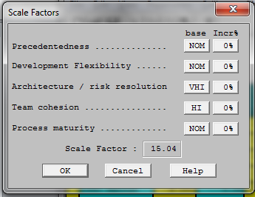
Table 11: COCOMOII Cost Driver-payment
Cost Driver | Value | Rationale
RELY | High | Once the system crashed, online shopper can’t use this module to do any purchase, which will result in high financial loss, since the online shopper can just search for items but can’t buy the products that they want to purchase.
DATA | Low | The database of payment module is only for storage the account number and payment history, which doesn’t need too much space of database.
DOCU | Nominal | All the documents in our project should exactly match to life-cycle needed since there doesn’t have stringent requirement for micro-level documentation, but must be adequate enough for further maintenance.
CPLX | Low | In payment module, we will use operations at physical I/O level to implement our project and some distributed processing.
RUSE | Low | There might has somewhere else need to use payment system, so this module is reusable but only across our project since this is a COTS which is original develop by our development team that can’t use to any other programs due to there might has some license issues.
TIME | Nominal | In our project, all the modules consume little computations and resources.
STOR | Nominal | The payment module doesn’t need to have a large storage to store all data that there has minor storage constraint.
PVOL | Low | In our system, the platforms are stable and are not required update or upgrade frequently.
ACAP | High | Five of six team members have certain extent experience in analysis but not maturity.
PCAP | High | Five of six team members have experience in the programming language that we are going to use in our project.
PCON | Low | Three of six team members may not plan to take CSCI577b.
APEX | Low | There’s only one team member has little experience in developing software system, and others just learned from lectures.
LTEX | Nominal | Five of six team members have some experiences in the writing JAVA; each member has about 2 years experiences in average. However, there still one beginner in the development team.
PLEX | Nominal | Every team member has little knowledge of understanding how to make the platform used in our system more powerful.
TOOL | Nominal | We don’t use strong, mature integrated software tools in our system; the only tool we use is very basic and moderately integrated software tool.
SITE | Nominal | All team members are in different cities and companies that the team can only hold meeting online.
Figure 4: COCOMO II EAF – payment
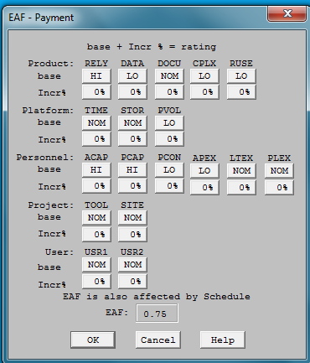
Table 12: COCOMOII Cost Driver- rank & review
Cost Driver | Value | Rationale
RELY | Low | Once the system crashed this module wouldn’t affect too much to the system, online shoppers can still do some purchase, also the losses from crash can easily recovery.
DATA | Low | There has some rank & review open source online that we can use it on our project, which it doesn’t take too many lines of code.
DOCU | Nominal | All the documents in our project should exactly match to life-cycle needed since there doesn’t have stringent requirement for micro-level documentation, but must be adequate enough for further maintenance.
CPLX | Nominal | The rank & review module sometimes use standard statistical routines and only required simple edit and some simple use of widget set.
RUSE | Very Low | This is a customized module so this can only fit on our system, but not for any other project or program usage in the future.
TIME | Nominal | In our project, all the modules consume little computations and resources.
STOR | Nominal | Since there doesn’t have large size of data in this module that there only has little storage constraint.
PVOL | Low | In our system, the platforms are stable and are not required update or upgrade frequently.
ACAP | High | Five of six team members have certain extent experience in analysis but not maturity.
PCAP | High | Five of six team members have experience in the programming language that we are going to use in our project.
PCON | Low | Three of six team members may not plan to take CSCI577b.
APEX | Low | There’s only one team member has little experience in developing software system, and others just learned from lectures.
LTEX | Nominal | Five of six team members have some experiences in the writing JAVA; each member has about 2 years experiences in average. However, there still one beginner in the development team.
PLEX | Nominal | Every team member has little knowledge of understanding how to make the platform used in our system more powerful.
TOOL | Nominal | We don’t use strong, mature integrated software tools in our system; the only tool we use is very basic and moderately integrated software tool.
SITE | Nominal | All team members are in different cities and companies that the team can only hold meeting online.
Figure 5: COCOMO II EAF – rank& review
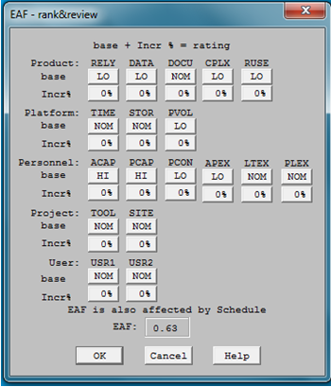
Table 13: COCOMOII Cost Driver- order management
Cost Driver | Value | Rationale
RELY | Nominal | If the system crashed then there will has a large loss since online shopper can’t do any purchase at that time.
DATA | Low | The database of order management module is only for storage the account number and order history, which doesn’t need too much space of database.
DOCU | Nominal | All the documents in our project should exactly match to life-cycle needed since there doesn’t have stringent requirement for micro-level documentation, but must be adequate enough for further maintenance.
CPLX | Low | In order management module, we will use operations at physical I/O level to implement our project and some distributed processing
RUSE | Low | The order management is for managing the orders that can also be used in other projects which would have similar requirement.
TIME | Nominal | In our project, all the modules consume little computations and resources.
STOR | Nominal | The order management module doesn’t need to have a large storage to store all data that there has little storage constraint.
PVOL | Low | In our system, the platforms are stable and are not required update or upgrade frequently.
ACAP | High | Five of six team members have certain extent experience in analysis but not maturity.
PCAP | High | Five of six team members have experience in the programming language that we are going to use in our project.
PCON | Low | Three of six team members may not plan to take CSCI577b.
APEX | Low | There’s only one team member has little experience in developing software system, and others just learned from lectures.
LTEX | Nominal | Five of six team members have some experiences in the writing JAVA; each member has about 2 years experiences in average. However, there still one beginner in the development team.
PLEX | Nominal | Every team member has little knowledge of understanding how to make the platform used in our system more powerful.
TOOL | Nominal | We don’t use strong, mature integrated software tools in our system; the only tool we use is very basic and moderately integrated software tool.
SITE | Nominal | All team members are in different cities and companies that the team can only hold meeting online.
Figure 6: COCOMO II EAF – order management
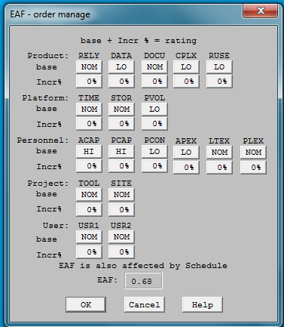
Table 14: COCOMOII Cost Driver - searching
Cost Driver | Value | Rationale
RELY | Nominal | Online shoppers can’t search for their desired products or products’ provider once the system crashed, but the losses can be easily be recovered and shoppers can still use payment module to pay the order already in shopping cart so it wouldn’t cause any financial losses.
DATA | Low | This module doesn’t have to store much data; the only work is to sending request and receives the response that we can implement this module by coding. Therefore, D/P is less than 10.
DOCU | Nominal | All the documents in our project should exactly match to life-cycle needed since there doesn’t have stringent requirement for micro-level documentation, but must be adequate enough for further maintenance.
CPLX | Nominal | We would use some simple nesting code and simple callbacks/ message passing to operate searching module. Also do I/O at GET/PUT level.
RUSE | Low | Many projects would use this module to search for their desired goods that this module is reusable for looking for products but not for searching some other information.
TIME | Nominal | In our project, all the modules consume little computations and resources.
STOR | Nominal | Due to there do not has lots data to be stored, so wouldn’t has too much storage constraint.
PVOL | Low | In our system, the platforms are stable and are not required update or upgrade frequently.
ACAP | High | Five of six team members have certain extent experience in analysis but not maturity.
PCAP | High | Five of six team members have experience in the programming language that we are going to use in our project.
PCON | Low | Three of six team members may not plan to take CSCI577b.
APEX | Low | There’s only one team member has little experience in developing software system, and others just learned from lectures.
LTEX | Nominal | Five of six team members have some experiences in the writing JAVA; each member has about 2 years experiences in average. However, there still one beginner in the development team.
PLEX | Nominal | Every team member has little knowledge of understanding how to make the platform used in our system more powerful.
TOOL | Nominal | We don’t use strong, mature integrated software tools in our system; the only tool we use is very basic and moderately integrated software tool.
SITE | Nominal | All team members are in different cities and companies that the team can only hold meeting online.
Figure 7: COCOMO II EAF – searching
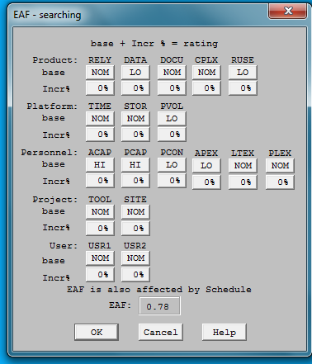
Table 15: COCOMOII Cost Driver – user management
Cost Driver | Value | Rationale
RELY | Nominal | Once the system crashed, system user can’t use this module to manage their information; however, the losses are easily recovery and wouldn’t affect to any financial loss.
DATA | High | The system will provide our product-providers to upload pictures on their profile, which would impose a large size of database.
DOCU | Nominal | All the documents in our project should exactly match to life-cycle needed since there doesn’t have stringent requirement for micro-level documentation, but must be adequate enough for further maintenance.
CPLX | Nominal | The user management module would provide users to upload their multimedia files and data, and also users can do some simply edit to their user page in user management module.
RUSE | Low | This module is based on the concept of user interface that this can also be used to other project which would like to use similar system, but there still has some customized function like multimedia upload that it’s only available to reuse across projects.
TIME | Nominal | In our project, all the modules consume little computations and resources.
STOR | Nominal | The system provides users to upload some pictures on their profile; the storage for this module doesn’t require too large constraint as videos and pictures in product management does.
PVOL | Low | In our system, the platforms are stable and are not required update or upgrade frequently.
ACAP | High | Five of six team members have certain extent experience in analysis but not maturity.
PCAP | High | Five of six team members have experience in the programming language that we are going to use in our project.
PCON | Low | Three of six team members may not plan to take CSCI577b.
APEX | Low | There’s only one team member has little experience in developing software system, and others just learned from lectures.
LTEX | Nominal | Five of six team members have some experiences in the writing JAVA; each member has about 2 years experiences in average. However, there still one beginner in the development team.
PLEX | Nominal | Every team member has little knowledge of understanding how to make the platform used in our system more powerful.
TOOL | Nominal | We don’t use strong, mature integrated software tools in our system; the only tool we use is very basic and moderately integrated software tool.
SITE | Nominal | All team members are in different cities and companies that the team can only hold meeting online.

Figure 8: COCOMO II EAF – user management
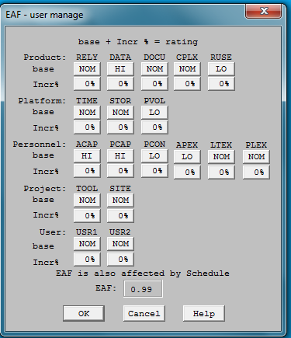

Table 16: COCOMOII Cost Driver – product management
Cost Driver | Value | Rationale
RELY | High | Project management is the most important module in our system, if the system crashed then the system user can’t do any purchase or product management that online shopper can’t buy products online which will cause financial losses.
DATA | Very High | In this module, the system provides some storage spaces to manage the product’s information including their pictures and videos, we estimate that we will write 2,200 lines of code and give every providers 5GB for multimedia, then the result of D/P would be very large.
DOCU | Nominal | All the documents in our project should exactly match to life-cycle needed since there doesn’t have stringent requirement for micro-level documentation, but must be adequate enough for further maintenance.
CPLX | Low | The product management module would provide users to upload their products’ picture files and data, also users can do some simply edit to their product page in this module.
RUSE | Very Low | This is a customized module so this can only fit on our system, but not for any other project or program.
TIME | Nominal | In our project, all the modules consume little computations and resources.
STOR | High | Since system provides users to upload multimedia data of their products online so the storage of this module might be much bigger than other modules so we give some more constraint on available storage.
PVOL | Low | In our system, the platforms are stable and are not required update or upgrade frequently.
ACAP | High | Five of six team members have certain extent experience in analysis but not maturity.
PCAP | High | Five of six team members have experience in the programming language that we are going to use in our project.
PCON | Low | Three of six team members may not plan to take CSCI577b.
APEX | Low | There’s only one team member has little experience in developing software system, and others just learned from lectures.
LTEX | Nominal | Five of six team members have some experiences in the writing JAVA; each member has about 2 years experiences in average. However, there still one beginner in the development team.
PLEX | Nominal | Every team member has little knowledge of understanding how to make the platform used in our system more powerful.
TOOL | Nominal | We don’t use strong, mature integrated software tools in our system; the only tool we use is very basic and moderately integrated software tool.
SITE | Nominal | All team members are in different cities and companies that the team can only hold meeting online.
Figure 9: COCOMO II EAF – product management
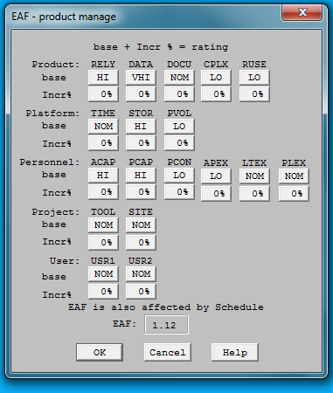

Figure 10: COCOMO II of Flowerseeker
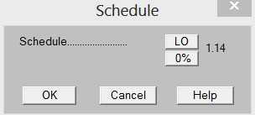

Figure 11: COCOMO II of FlowerSeeker
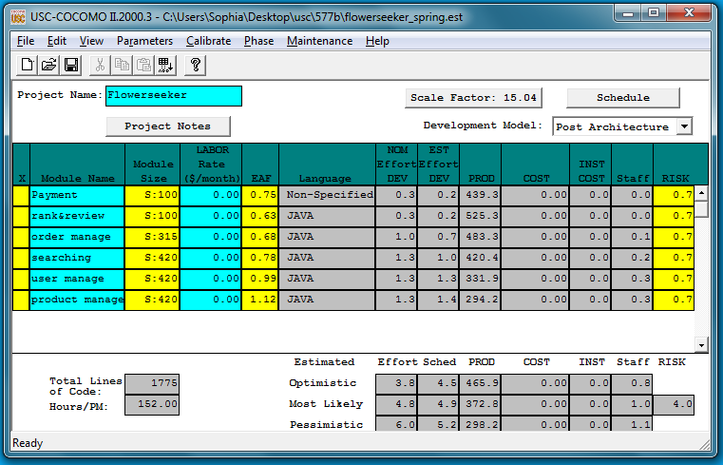

Iteration Plan

Plan
We plan three iterations to develop our system based on our capability goals and modules. First iteration focus on develop the most important capabilities in our system: searching (searching module), upload pictures (product module) and subscription (user module). In second iteration, we develop rank & review (rank & review module) and order (order module) capabilities. And we plan to develop coupon, upload video and recommendation function in the third iteration, since these three functions are in second priority. According to course schedule, our milestone set on Feb. 6 (before RDCP ARB) and Apr. 10 (before TRR ARB).
Iteration 1: 02/16/13 – 03/02/13
Iteration 2: 03/03/13 – 04/06/13
Iteration 3: 04/07/13 – 04/19/13

Capabilities to be implemented
Table 17: Construction iteration capabilities to be implemented
ID | Capability | Description | Priority | Iteration
OC-1 | Search functionality | The system is capable of searching product by location, occasion, ranking, etc. | 1  (Must have) | 1
OC-2 | Upload pictures | The system is capable of uploading pictures for product by florist. | 1  (Must have) | 1
OC-3 | Ranking & Review | The system is capable of creating and updating rank and review to customer by florist and to product and florist by customer. | 1  (Must have) | 1
OC-4 | Order Management | The system is capable of showing order history and status for florists to see how many customers purchased flowers from this florist. And also for online shoppers to check the order history to track previous orders they placed. | 1  (Must have) | 1
OC-5 | Subscription | The system is capable of making subscription and pay monthly fee by premium user. | 1  (Must have) | 2
OC-6 | Coupon Generation | The system is capable of generating coupons for florists to promote their products to specific customers. | 2  (Could have) | 2
OC-7 | Upload Video | The system is capable of uploading videos for product by florist. | 2  (Could have) | 3
OC-8 | Recommendation Engine | The system is capable to recommending customers | 2  (Could have) | 3

Capabilities to be tested
Table 18: Construction iteration capabilities to be tested
ID | Capability | Description | Priority | Iteration
OC-1 | Search functionality | The system is capable of searching product by location, occasion, ranking, etc. | 1  (Must have) | 1
OC-2 | Upload pictures | The system is capable of uploading pictures for product by florist. | 1  (Must have) | 1
OC-3 | Ranking & Review | The system is capable of creating and updating rank and review to customer by florist and to product and florist by customer. | 1  (Must have) | 1
OC-4 | Order Management | The system is capable of showing order history and status for florists to see how many customers purchased flowers from this florist. And also for online shoppers to check the order history to track previous orders they placed. | 1  (Must have) | 1
OC-5 | Subscription | The system is capable of making subscription and pay monthly fee by premium user. | 1  (Must have) | 2
OC-6 | Coupon Generation | The system is capable of generating coupons for florists to promote their products to specific customers. | 2  (Could have) | 2
OC-7 | Upload Video | The system is capable of uploading videos for product by florist. | 2  (Could have) | 3
OC-8 | Recommendation Engine | The system is capable to recommending customers | 2  (Could have) | 3

Capabilities not to be tested
All capabilities will be tested after each iteration.

CCD Preparation Plans
There will have one client and two development team members participate in CCD presentation. Development team will provide a brief instruction for client to practice system; and also create a feedback form for client to fill in to see if there have any other parts that development team can improve or not
Also, the team members will provide a user manual on the capabilities to be presented, more specifically on the administrative, customer and florist system role.
Team will provide two laptops computers fully equipped to run FlowerSeeker demo.

Iteration Assessment

Capabilities Implemented, Tested, and Results
Table 19: Capabilities implemented, tested, and results
ID | Capability | Test Case | Test Results | If fail, why?
1 | Existing user can successfully login | TC-01-01 Login | Pass
2 | Error message show up if type wrong username or password | TC-01-02 Incorrect Login | Pass
3 | User can successfully log out to home page | TC-01-03 Logout | Pass
4 | Right product in searched zip code displayed | TC-02-01 Search by location | Pass
5 | Product in selected price range displayed | TC-02-02 Search by price | Pass
6 | Product in selected occasion displayed | TC-02-03 Search by occasion | Pass
7 | Product in selected rating displayed | TC-02-04 Search by rating | Pass
8 | User can successfully register as a new florist | TC-03-01 Register new florist | Pass
9 | Error message show up when if some field doesn’t be filled in or username has already been used | TC-03-02 Register florist failure | Pass
10 | Florist can successfully add new product to product list | TC-04-01 Add new product | Pass
11 | Error message show up if there’s some missing information doesn’t fill in | TC-04-02 Add invalid product | Pass
12 | Customer list correctly displayed | TC-05-01 Show customer list | Pass
13 | Customer detail displayed when click on specific customer page | TC-05-02 Show customer detail | Pass
14 | System can generate coupon for customer | TC-05-03 Generate coupon | N/A | This function will be generated in next iteration
15 | System can show placed orders | TC-07-01 Florist Order History | Pass
16 | Order detail page displayed when chosen | TC-07-02 Florist Order Detail | Pass
17 | The updated order status can be displayed | TC-07-03 Update Order Status | Pass
18 | User can rank specific product | TC-09-01 Rank product | Pass
19 | User can review all products | TC-09-02 Review product | Pass
20 | Customer’s order history can be displayed correctly | TC-10-01 Customer Order History | Pass
21 | Order detail page can be displayed | TC-10-02 Customer Order Detail | Pass
22 | All the premium subscribers are shown in system correctly | TC-11-01 Premium Subscribers info | Pass
23 | User can successfully register as a new customer | TC-12-01 Register new customer | Pass
24 | Error message show up when if some field doesn’t be filled in or username has already been used | TC-12-02 Register customer failure | Pass

Adherence to Plan
Team followed iteration plan and remained faithful for almost all proposed activities, we were able for finish almost all proposed capabilities except Recommendation engine capability. Despite the delay on it here are some positive aspects of the construction iteration:
- The order on the development of the capabilities remained faithful. By doing this, we were able to present continues prototype feedback to the client.
- All Team members worked on their assigned tasks by the role given. By doing this, it was easy to share domain knowledge by asking the person who created or tested a specific part module of the system.
Here are some failures found in the past iteration:
- Testing activities started one week late compared to the proposed date
- Client delayed the creation of Amazon E2C account. This situation restrained the earlier testing and upload of the system in the final context environment.
- Checkout process wasn’t fully developed. Even though the coding checkout module on a sandbox paypal coding account was finish on time, it didn’t go fully operational because client has not created a PayPal account neither defined the fees and rates she’s going to use for the flowers sales.

